Jazz Courter

Purpose

The purpose of this assignment is to introduce you to Microsoft Power BI Service. This is the web version of Power BI. You will learn to access the tool, load a Power BI Application, and to use the tool to explore the application. This assignment will provide the foundation for the use of this tool throughout this course.

You may want to answer the following questions by following along with the LIL Tutorial for this Module.

Open Power BI Service and read the article titled "Getting Started with Power BI" available on the home page of Power BI Service.
Microsoft Power BI Service

- A Power BI App is a set of report/s and dashboard/s available for the business users of the Power BI Service.
  - Select Apps from the Power BI left navigation menu.
  - Click the green Get Apps button in the upper right corner of the screen.
  - Scroll and find the Sales and Marketing Sample App.
  - Load this App into Power BI.
  - This is the App used in the Linked in Learning Tutorial for this Module.
(I don’t seem to have full access to PowerBi and have submitted an IT ticket to fix this issue.
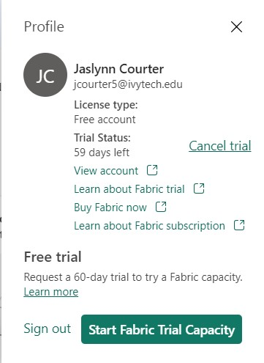
)
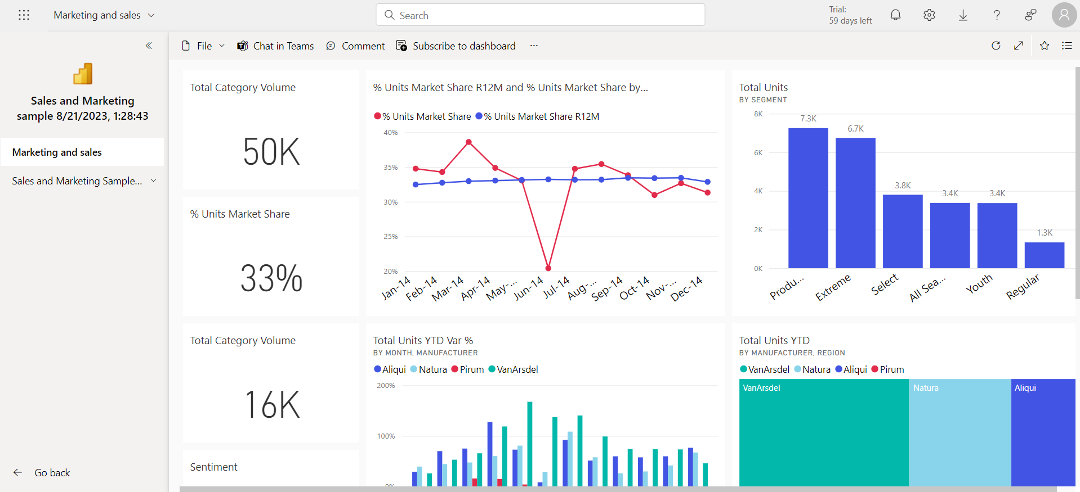

- Using Power BI "Ask a question about your data", answer the following questions:
  - Which Manufacturer has the most units? VanArsdel How many? 6,114
  - Which Manufacturer has the least units? Palma How many? 154
  - How many units were manufactured in Indiana? 105
  - Screen print the chart produced for the first two questions and paste it here.
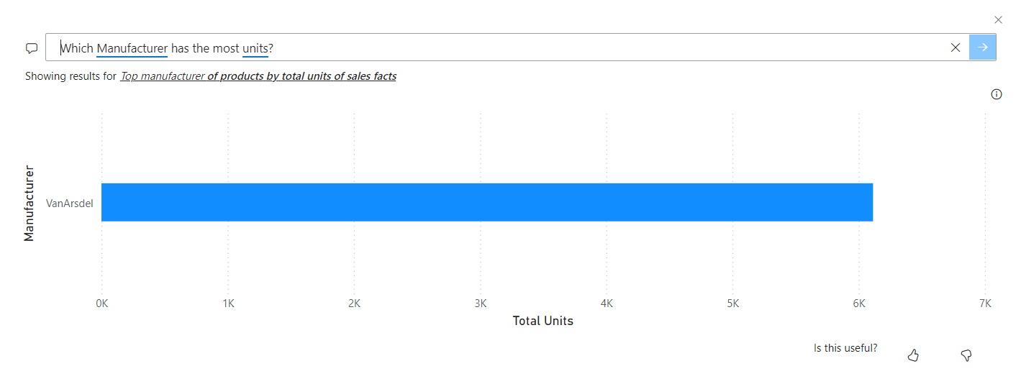
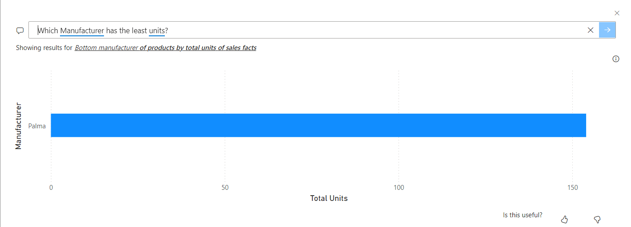

- Subscribe yourself to this dashboard.
Paste here a copy of an email you received from this subscription.
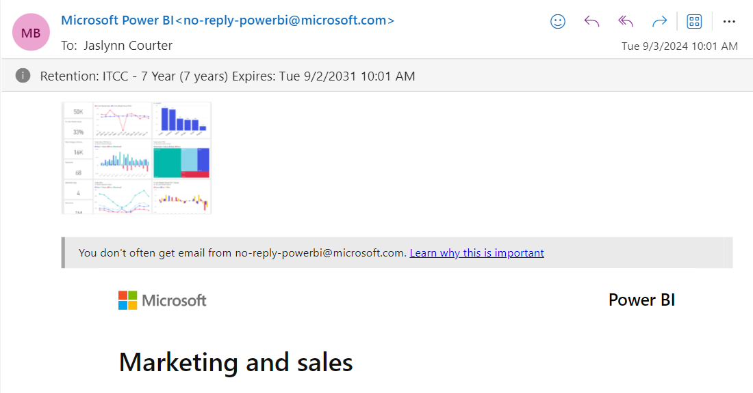

- Add a comment to the dashboard.
Screen print the comment and paste it here.



- Select one of the visual tiles on the dashboard.
Copy the visual as an image and paste it here.
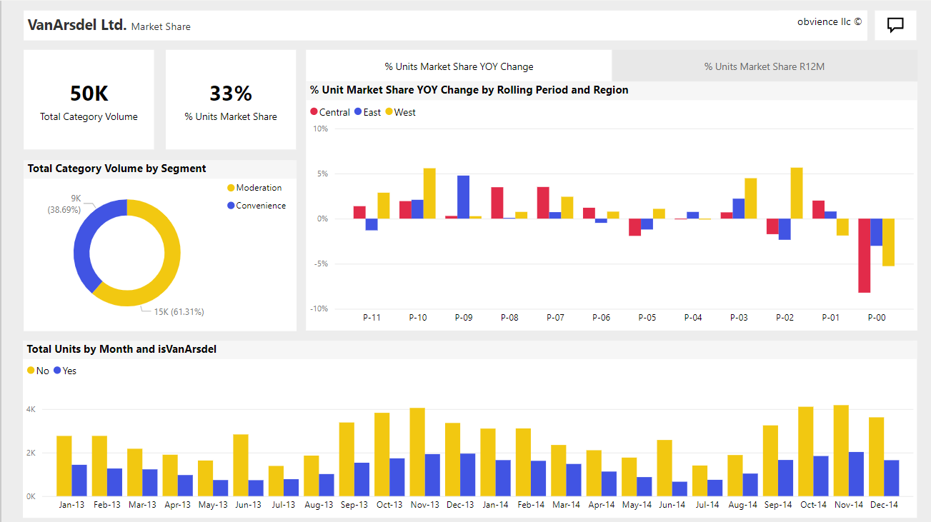

- Select one of the visual tiles on the dashboard.
  - Open in Focus Mode.
  - Screen print the tile and paste it here.
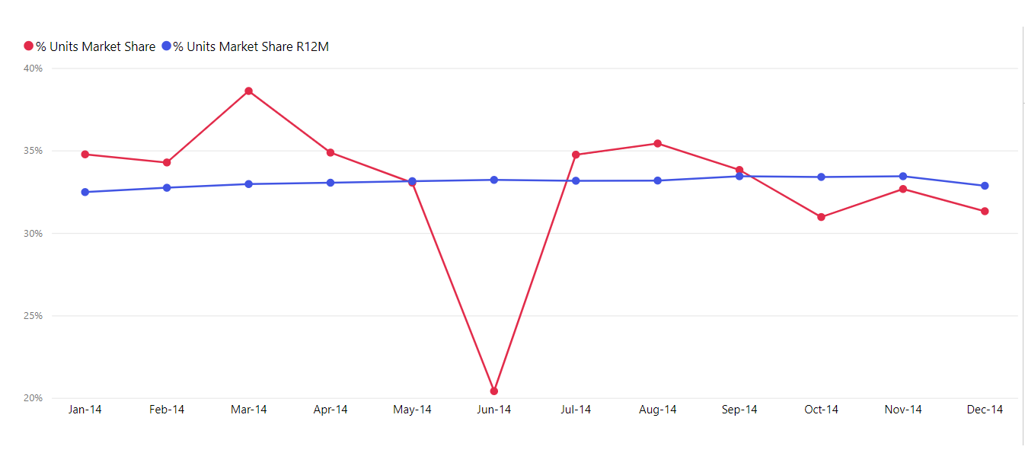
  - Export the data behind this tile to Excel and paste up to 10 rows of the data here.
% Units Market Share R12M | % Units Market Share | Month
32.47% | 34.76% | 14-Jan
32.74% | 34.27% | 14-Feb
32.96% | 38.60% | 14-Mar
33.04% | 34.87% | 14-Apr
33.14% | 33.04% | 14-May
33.21% | 20.41% | 14-Jun
33.16% | 34.74% | 14-Jul
33.17% | 35.42% | 14-Aug
33.44% | 33.82% | 14-Sep

  - Select View Insights on this tile. Screen print the insights and paste here.
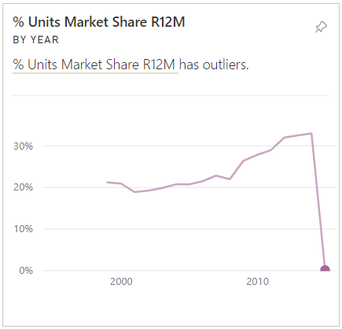
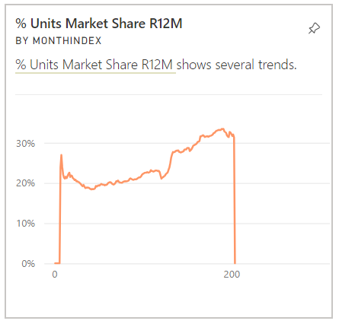
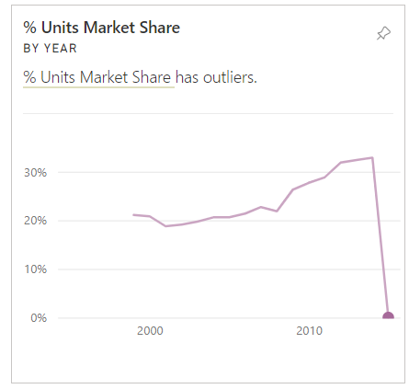
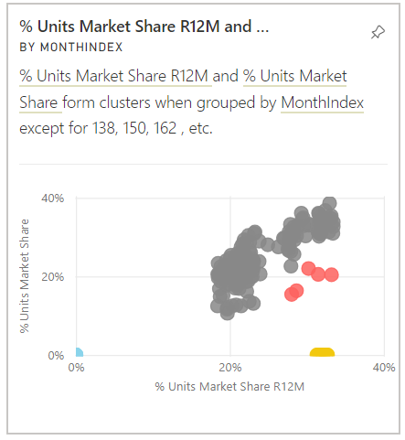
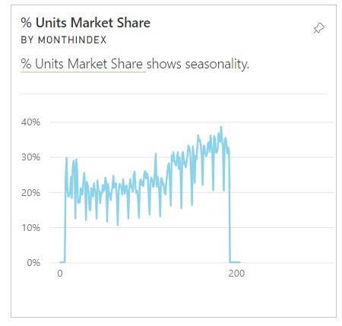
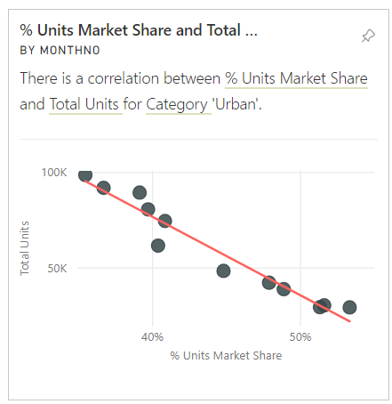
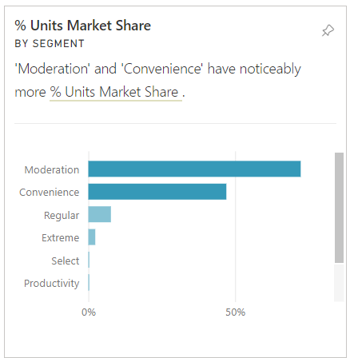
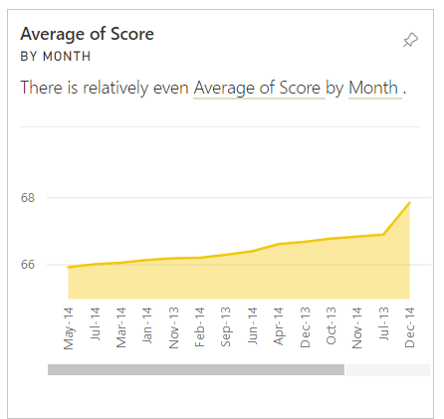

- Open the "YTD Category" page of the report.
  - Create a bookmark for this report.
  - Screen print the report and paste it here.
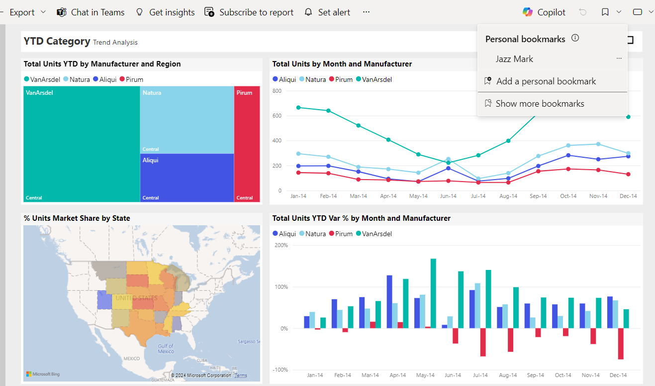

- Select one of the visuals from the "YTD Category" page and select "show as a table". Screen print this image and paste it here.
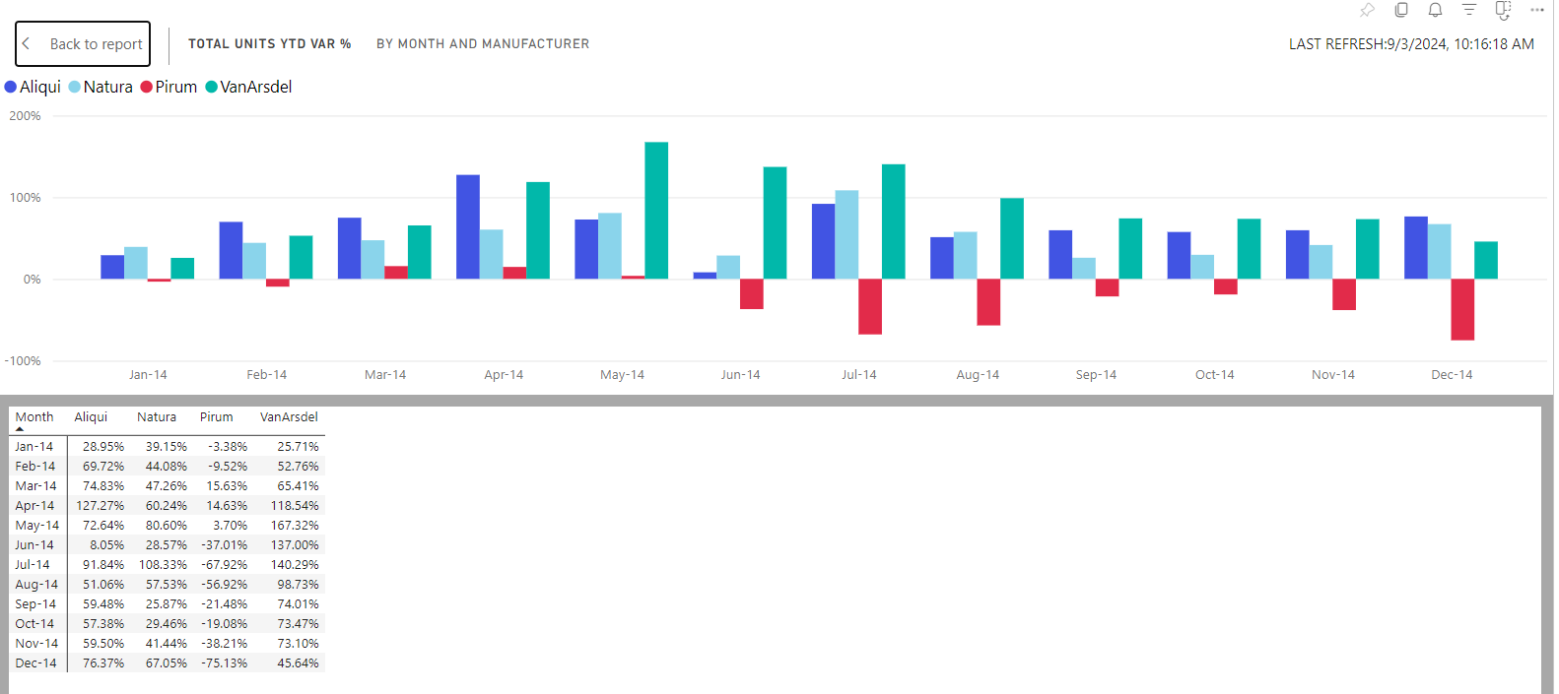

- Select the map visual on the "YTD Category" page. Cross filter this page.
  - Select Indiana.
  - Screen print the report and paste it here.
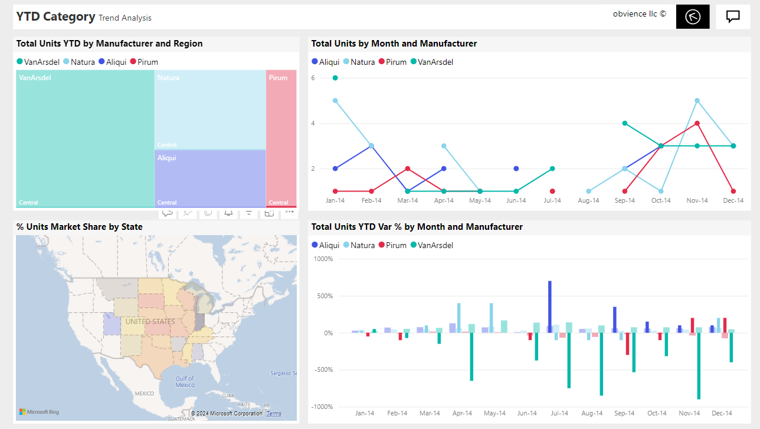

- Export the "YTD Category" report page.
  - Export as a PDF file and attach the file here.
  - Export as a Power Point file and attach the file here.

